DIT5401
Internet & Web Publishing

Trimester 2, Session 2020 / 2021

Project Title:

BY

No. |  | Student ID |  | Student Name

Table of Contents
TABLE OF CONTENTS 1
TASK DISTRIBUTION FORM 2
PROJECT EVALUATION FORM 3

PART 1: INTRODUCTION 4

PART 2: SCREENSHOTS OF THE WEBPAGE 5

REFERENCES 6
APPENDIX (Meeting Minutes) 7

TASK DISTRIBUTION FORM

No. | Student ID | Student Name | Tasks Completed | Signature
 |  |  | ie. Homepage, JavaScript, drop-down menu

DIT5401 Internet & Web Publishing
PROJECT EVALUATION FORM

STUDENT ID | STUDENT NAME | Peer Evaluation Total Marks (20M)  (For Evaluator Use) | Project + Peer Evaluation  (For Evaluator Use)  (40M+20M)

1 | Very Poor | 2 | Poor | 3 | Average | 4 | Good | 5 | Excellent

Criteria | Marks | Comments/ Remarks
- Content (User/Customer)
- Content relevance, appropriateness, organization and presentation
- Content (Administrator):
- Content relevance, appropriateness, organization and presentation
- Graphics & CSS
- Hyperlinks
- Form
- Extra features (video, javascript)
- Overall design
- Report (Hard copy & Softcopy)
Total (40)

PART 1: INTRODUCTION

This section describes the topic selection and explain/list the web pages that you have developed.

PART 2: SCREENSHOTS OF WEBPAGE

This section includes screenshots for each web page(including user and administrator).

Example screenshot:
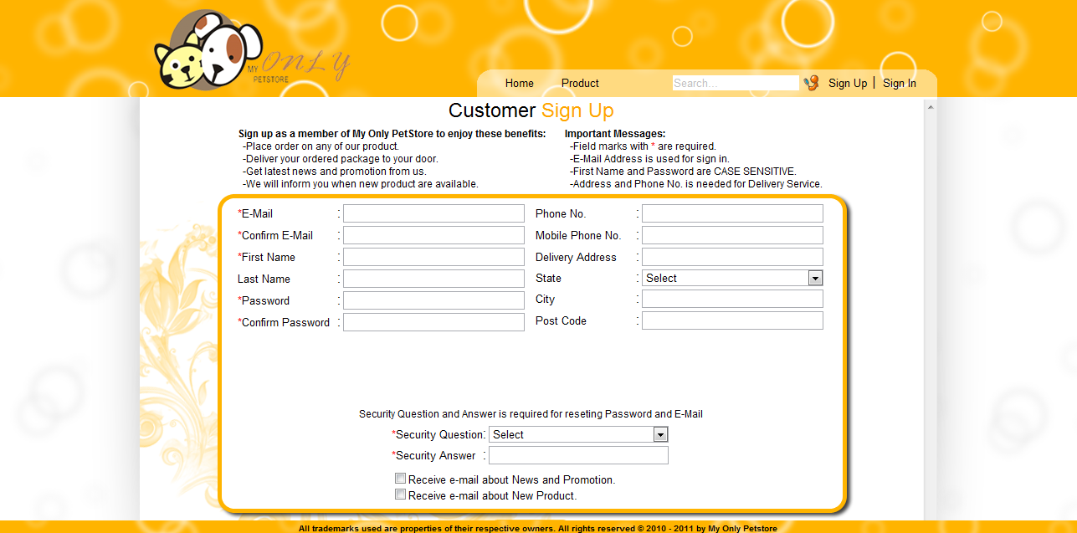

Figure 1. Customer Sign up Page

REFERENCES/BIBLIOGRAPHY
List of URL addresses or reference books

APPENDIX

Meeting No. | 1
Project Title | Cookies Ordering System
Date | 21 August 2019
Time | 2.00 p.m. – 4.15 p.m.
Venue | MBMR3023

ATTENDANCE
Present | Absent
- Ali Hassan  - Raj Kumar | - Jackson Lee

NO | ITEM | INFO/ACTION
1 | - Discuss on the dates and time for each meeting to be held.  - Decision was made that every Thursday from 8:00 p.m. to 11:00 p.m will be the meeting time. | All
2 | - Each Group member have to find 2 websites related to the project title.  - Ali have to do research on how to create a CSS based web page layout.  - Jackson have to …. | All  Ali  Jackson

The meeting adjourned at 4:15 p.m.
Prepared by:

Raj Kumar

